**USDA Forest Service**

**Huron Shores Ranger Sation**

**5761 N Skeel Ave**

**Oscoda, mi 48750**

**Summary of Red pine bole char Data**

On The Huron National Forest

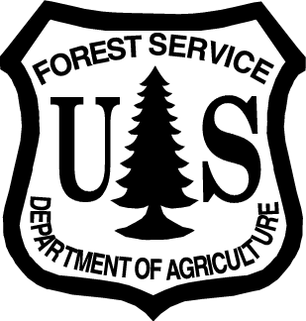

Prepared by: __Brian Stearns________________ Date: ___05/15/2012_

Assistant Module Leader

Huron-Manistee Interagency Wildland Fire Module

**Purpose**

The information in this summary is based on data gathered by the Huron Shores Prescribed Burning Program on the Huron-Manistee National Forest. The prescribed burn projects consisted of Brittle Landscape Prescribed Burn Project, Memorable Prescribed Burn Project, and South Branch Wickert Hills. Projects were conducted from 2004 to present day. All of the projects were located in the Tawas District of the Huron National Forest in Iosco County, Michigan (figure 1).

**Figure 1. Area map showing the burn units**

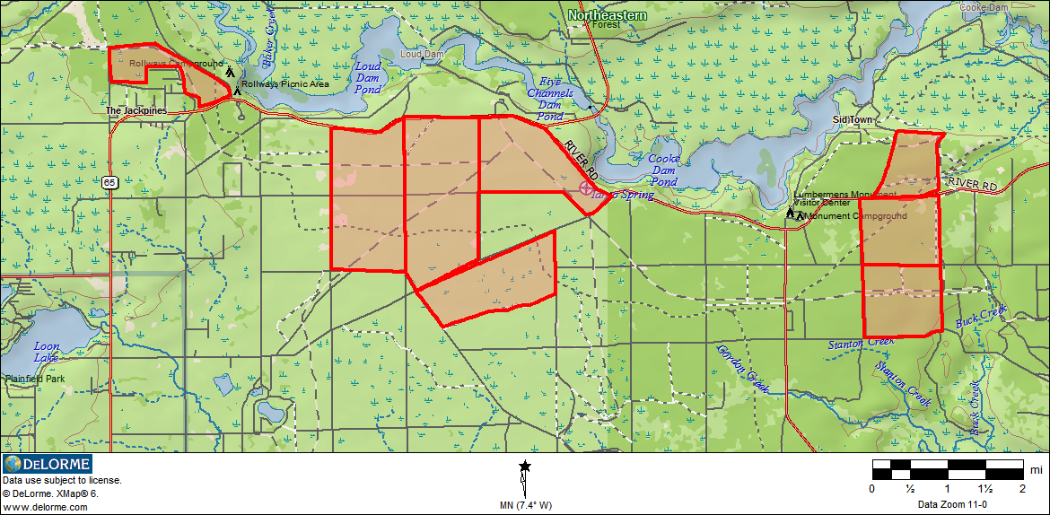

**Background**

The burn units are approximately 91% forested, consist of 98% ground cover, are almost entirely comprised of dry sandy plains, and major precipitation events occur when soils are frost-free. The onsite conditions are favorable for good water infiltration and sub-surface percolation. Average age of the overstory is 50-70 years, and is comprises of primarily red pine (pinus resinosa), northern pin oak (quercus ellipsoidalis), and some jack pine (pinus banksiana). All of the burn units have had some harvest activates to thin the stands. Surface fuels are comprised primarily of needle cast and Pennsylvania sedge (Carex pensylvanica). The pre-burn primary fuel models are the standard TU2, and TL6 with main fuel being grasses, sedges, blueberry, and needle cast. In Brittle burn blocks 4, 9, and 10 pockets of slash from logging activities existed typically 12’ X 12’. The pockets of slash increased fire behavior within those areas. Fuel loading is displayed in table 1.

**Table 1. Fuel Loading Information**

|  |  |  |  |  |  |  |  |  |
| --- | --- | --- | --- | --- | --- | --- | --- | --- |
| PREBURN | | | |  | POSTBURN | | | |
| Block # | BLK 4 | BLK 10 | Average |  | Block # | BLK 4 | BLK 10 | Average |
| **1 hr** | **0.029** | **0.032** | 0.031 |  | **1 hr** | **0.029** | **0.018** | 0.024 |
| **10 hr** | **0.119** | **0.119** | 0.119 |  | **10 hr** | **0.119** | **0.079** | 0.099 |
| **100 hr** | **0.216** | **0.271** | 0.244 |  | **100 hr** | **0.216** | **0.222** | 0.219 |
| **1000 hr Solid** | **0.549** | **3.428** | 1.989 |  | **1000 hr Solid** | **0.476** | **2.746** | 1.611 |
| **1000 hr Rotten** | **1.796** | **4.078** | 2.937 |  | **1000 hr Rotten** | **1.598** | **2.423** | 2.011 |
|  |  |  |  |  |  |  |  |  |
| **Litter loading** | **7.297** | **9.035** | 8.166 |  | **Litter loading** | **1.992** | **1.485** | 1.739 |
| **Duff loading** | **6.882** | **11.426** | 9.154 |  | **Duff loading** | **4.206** | **8.475** | 6.341 |
| **Litter depth** | 1.54 | 1.84 | 1.69 |  | **Litter depth** | 0.35 | 0.30 | 0.32 |
| **Duff depth** | 0.84 | 1.23 | 1.04 |  | **Duff depth** | 0.50 | 0.92 | 0.71 |

**Method of Data Collection**

Huron Zone fuels / fire monitoring begins with pre-burn brown’s transects, tree mortality inventory, and photo plots to determine the baseline fuel loading. The number of plots is based on acreage, and the locations of the plots are generated randomly. The method of collecting the data is standardized and is outlined in “Huron Shores Downed Woody Debris / Fire Effects Monitoring Plots Handbook”. This handbook is designed as a quick reference for fire effects monitoring protocol on the Huron-Manistee. The sampling design is based on James K. Brown’s “Handbook for Inventorying Downed Woody Material” (GTR-INT16, 1974), the National Park Service’s “Fire Effects Monitoring Handbook.” The tree mortality inventory for the Huron zone has been developed with resource specialists input from wildlife and forestry and focus on several variables including bole char (figure 2 is an example of the tree mortality data sheet). The information used in this summary was filtered to show only red pine data.

Figure 2. Example of Tree Mortality Inventory



**Summary of Data**

The bole char information has been presented with the burn day observations to illustrate the fire behavior and environmental conditions that contributed to the bole char (Table 2).

**Table 2. Bole Char Data**



For some of the projects data was collected at 2 years post-burn and again at 5 years post-burn. Table 3 illustrates all of the post-burn bole char data. Most of the red pine had small amounts of char at or near the original post burn levels. The General observations recorded for bole char a 5 years post-burn was of the base of the bole (up to 1’) where the bark was thickest still had significant bole char. Higher on the bole were the bark started to become thinner and scalier the bole char was less prominent.

**Figure 3. Bole Char in Red Pine**

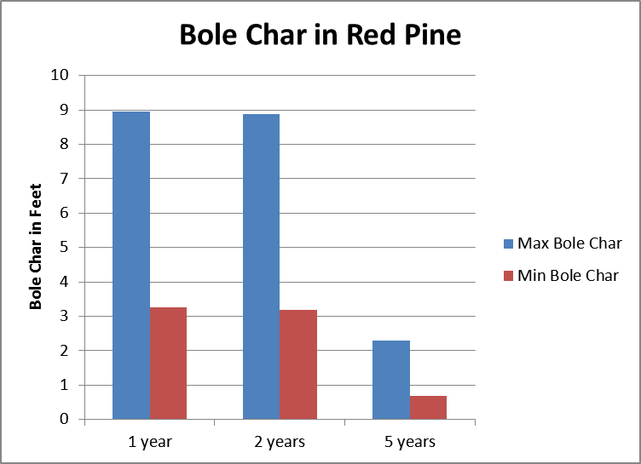

|  |  |
| --- | --- |
| Examples of 5 years post-burn conditions Brittle landscape Prescribed Burn (taken 3’ apart) | |
| E:\Fuels Management\Fuels Monitoring\Bole Char\P5150261.JPG | E:\Fuels Management\Fuels Monitoring\Bole Char\P5150262.JPG |

The observations and data collected for the Huron Shores Fuels Monitoring Program is consistent with information found on Fire Effects Information System www.fs.fed.us/database/feis/. Additional questions or request for plot data should be directed to:

Brian Stearns

Huron Shores Ranger Station

5761 N. Skeel Ave.

Oscoda, MI 48750

989-739-0728 ext. 3111

bstearns@fs.fed.us

**References;**

Neary, Daniel G.; Ryan, Kevin C.; DeBano, Leonard F. 2005. Wildland fire in ecosystems: effects of fire on soils and water. Gen. Tech. Rep. RMRS-GTR-42-vol.4. Ogden, UT: U.S. Department of Agriculture, Forest Service, Rocky Mountain Research Station. 250 p.

Benzie, John W. 2005. A Revised Manager’s Handbook for Red Pine in the North-Central States. USDA Forest Service Gen. Tech. Rep. NC-33, 22 p. North Central Forest Experiment Station, St. Paul, MN.

James K. Brown’s “Handbook for Inventorying Downed Woody Material” (GTR-INT16, 1974)

The National Park Service’s “Fire Effects Monitoring Handbook.” Fire Management Program Center

National Interagency Fire Center

Interagency Prescribed Fire, planning and implementation procedures reference guide. (September 2006)